Interpretation of Windows System Information Batch File

Lane Dorscher
CS200-T301 Systems Fundamentals (2261-1)
Bellevue University
11/02/2025
Joseph Kovacic

Introduction
This batch file was created to gather and display essential system information from a Windows computer using built-in command-line tools. Each command serves a specific purpose that contributes to understanding the computer’s configuration and performance. The script begins with @echo off, which prevents the command prompt from displaying each line of code as it executes. This helps make the output cleaner and easier to read. The command cls clears the screen, ensuring that the information displayed is not mixed with any previous terminal output. The screenshots can be seen before the references after the conclusion.

Interpretation of Commands
The section labeled “OS Info” uses systeminfo | findstr /B /C:"OS Name" /C:"OS Version". This command filters the output of the systeminfo utility to show only the operating system’s name and version number. This is important for verifying which version of Windows is installed and ensuring compatibility with software and updates.
Next, the script retrieves processor details using wmic cpu get name, loadpercentage. The Windows Management Instrumentation Command (WMIC) queries the CPU for its model name and current load percentage, providing insight into both the hardware specifications and real-time usage.
Finally, the line systeminfo | find "Virtual Memory" displays details related to virtual memory, which is Windows’ implementation of address translation. Virtual memory allows the system to use hard drive space as temporary RAM, improving performance when physical memory is low.

Conclusion
Overall, this batch file efficiently automates the retrieval of critical system information, providing a quick and readable report for system administrators or users interested in their computer’s hardware and memory configuration.
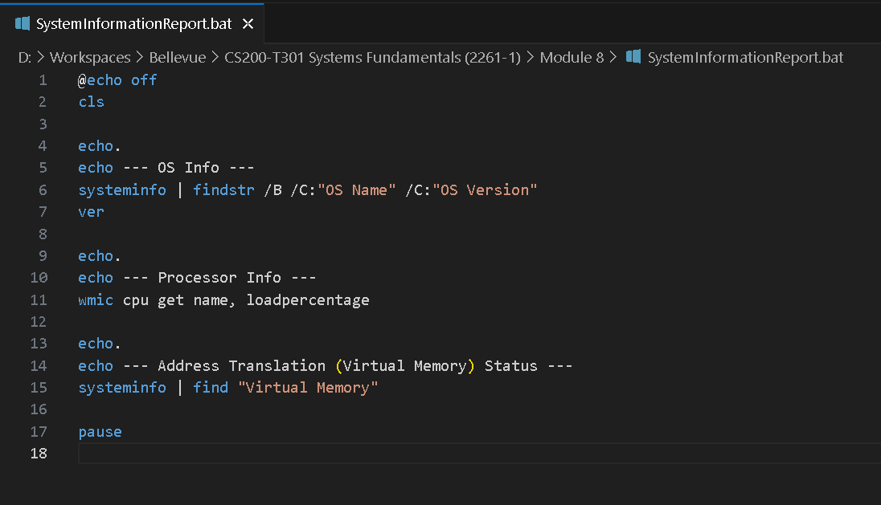
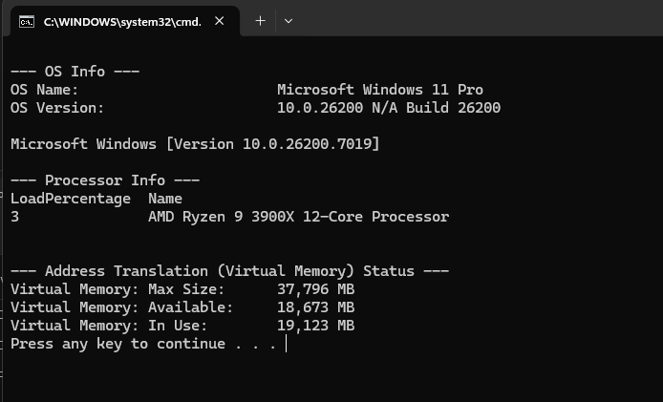
Reference
Microsoft. (n.d.). System information (systeminfo). Microsoft Learn. Retrieved from https://learn.microsoft.com/en-us/windows-server/administration/windows-commands/systeminfo

